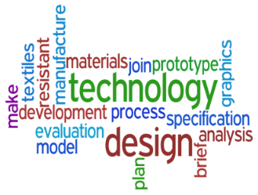
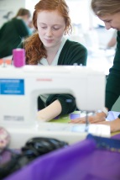
Key Stage 4
Design and Technology
Fashion Textiles Technical Award (AQA)

Please note that the details of the draft specification are yet to be confirmed.

What type of students enjoys this course?
For this subject, you must be motivated, enthusiastic, enjoy being creative and be a keen problem solver. It is essential that you can work as part of a group and independently. A willingness to work hard and a general interest in fashion and textiles is essential.

Subject Content:
Teacher Assessed Unit 1: Skills Demonstration
Students will make 3 or 4 products which demonstrate 12 practical skills specified by AQA. Some examples of these skills are; methods of applying colour to fabric, surface embellishment, applying fastenings and components, garment construction. In Unit 1 students will also be assessed on their teamwork skills by working with others on a small practical project.

Teacher Assessed Unit 2: Extended Making Project
Students will make a single product in response to AQA set tasks. Alongside this they will produce a folder to evidence planning , development, testing and evaluation.

AQA Assessed Unit 3: Examination. The Fundamentals of Fashion and Textiles.
Students will be assessed on their knowledge of materials and their properties and of commercial and industrial practices within the fashion and textiles industry. They will also learn about related career opportunities.

How the course is assessed:
Unit 1: Mini Projects to show the 12 practical skills. (30%)
Unit 2: Extended Project building on the skills developed in Unit 1. (30%)
Unit 3: AQA Assessed Examination. The Fundamentals of Fashion and Textiles. (40%)

What could this qualification lead to?
Courses such as :
Level 2 Diploma in Art and Design
Level 3 Extended Diploma in Art and Design
A levels such as Art or Fashion and Textiles
Careers such as:
Fashion Design Interior Design Teaching
Textiles Surface Design Footwear Designer Milliner Garment Technology Textiles Historian Print Design
Pattern Design Fabric Scientist
Fashion Journalist Costume Designer
Fashion Illustration Lingerie/Swimwear Designer

For further information, please see Ms Addison or Mrs Williams.

